Final Project Design Phase
Computer Science - Week 11
Oct 3, 2026 - Version 0.0.4

For complete instructions and project ideas, refer to the assignment in Canvas. Specifically, review the final project requirements before you continue below. If you have not reviewed the project requirements in Canvas (you might have to go to the modules view and check the current or past week's content), you will not be able to properly complete the parts below. In addition, it may be helpful to review the information on this Drafter documentation page.

0) Project Planning and Preparation
Successful programmers spend time planning before they begin coding. After reviewing the project requirements, answer the following questions to help guide your design and development process.
- What concepts from class or previous assignments might help you complete this project? Which programming concepts (loops, conditionals, lists, classes, etc.) do you expect to use? What programming skills do you want to improve while completing this project?
I think using the concepts of dataclasses and conditionals will help to store information and provide accurate recommendations. I want to improve my ability to write more complex code and integrate dataclasses into functions.

- Which parts of the project do you expect to be the easiest for you? The hardest? Why?
I expect the inputting to be the easiest as I just have to store the information but then processing the information and outputting the best recommendations could be the hardest.

- Even though you have not yet designed the final project, estimate which tasks will likely require the most time and effort? Which features or components should be implemented first?
The task of creating and researching books that fit certain criteria and ideas for good recommendations will require the most time and effort. The first feature or component that should be implemented is the inputs and the dataclasses that collect and store information from the user in order to provide accurate recommendations.

- What distractions might interfere with your work and how will you minimize them? What resources will you need available while working? What questions, if any, do you still have about the assignment requirements?
Distractions that might interfere with my work could be work for other classes and studying for possible exams. I can minimize this by doing my work ahead of time and completing work rather than procrastinating it. I will need the resources of my notes and my old work in the class. I have no other questions about the assignment requirements.

1) Site Diagram
Create a mock-up of your planned website. We suggest you make the mockup on paper, although you can also use software like PowerPoint or Slides to make a mockup. There is other design software that could also be used, but we strongly encourage you to keep it simple. Do not spend more than 15-30 minutes detailing the mock-up. Your goal should be to make a very quick and dirty diagram, to show that you have some kind of idea.

We recommend drawing each page as a rectangle, and laying out the text, buttons, and other components inside. Then, use arrows to indicate links between pages. Label each page the way you will name each function, and then put labels on the arrows to indicate what the button links. Also write down any parameters that should come into the pages.

In addition to the pages and routes, write down what fields your `State` will have, both their names and types. Think clearly about what data will need to be persistent across the entire website.

Add photo(s) or screenshot(s) of your website mock-up and labeled diagram on the next page.

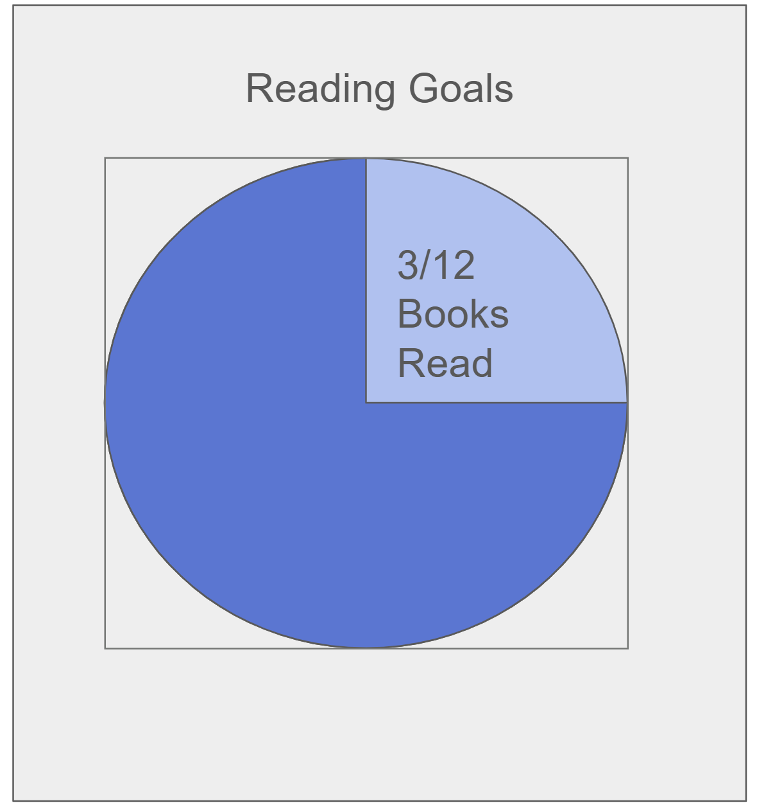
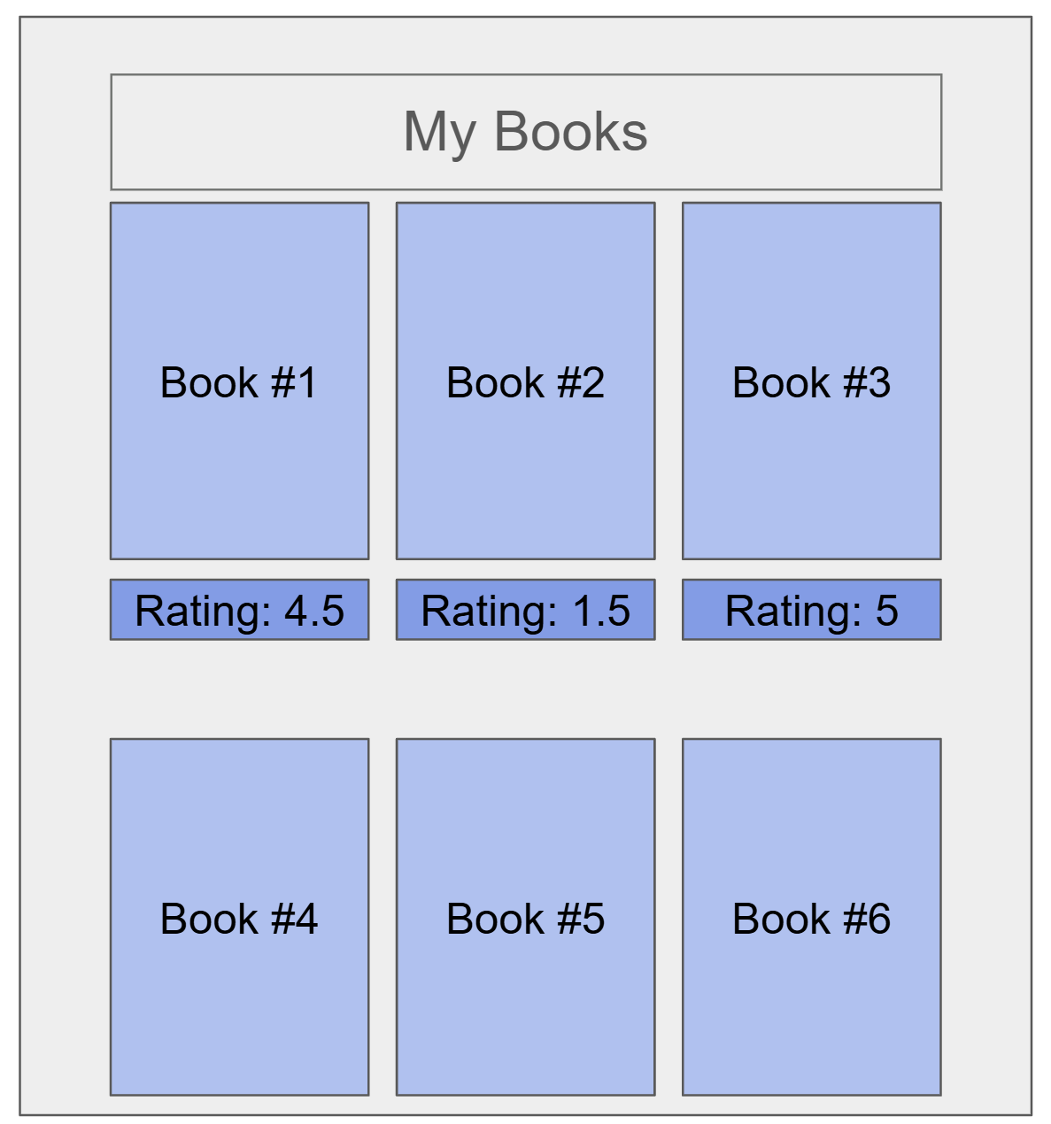
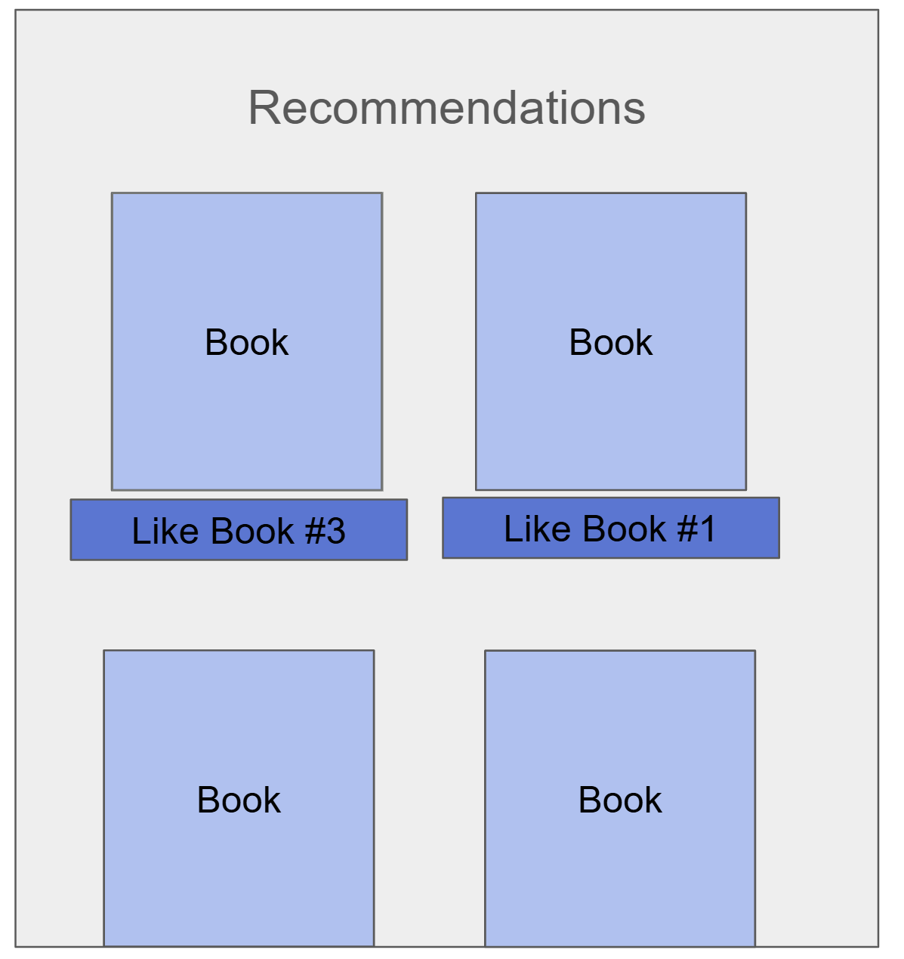
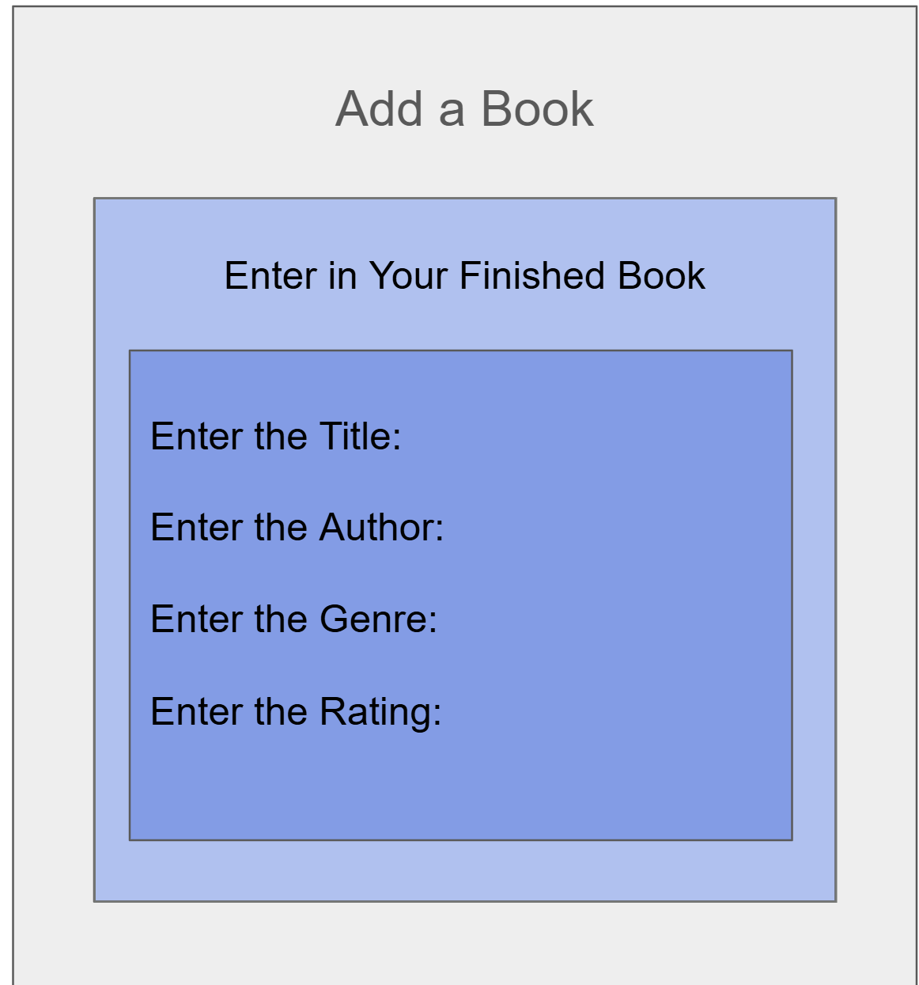
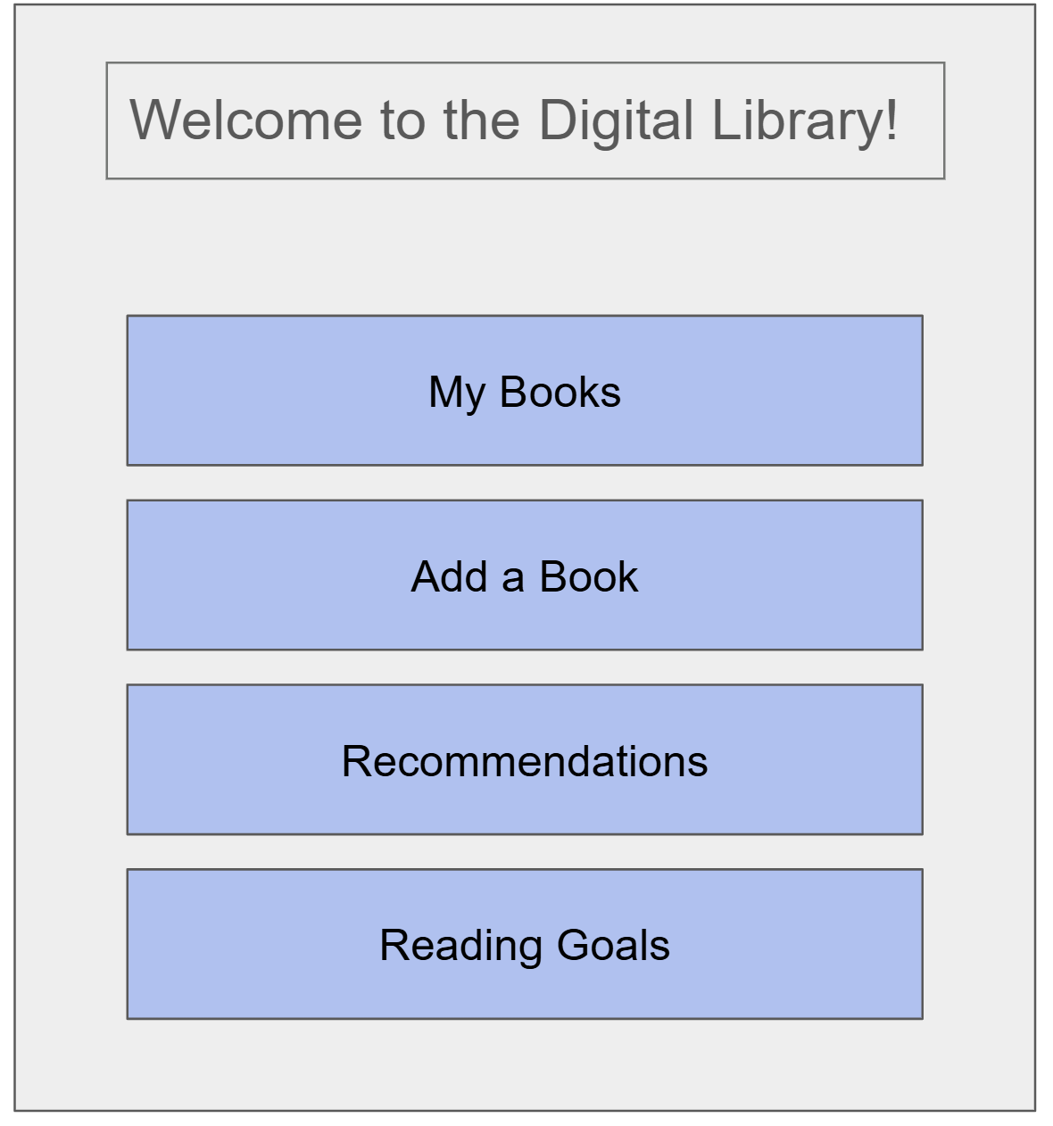
2) Implementing Requirements
This table should serve as a draft for how you will implement the requirements into your final project. You may change your ideas later on, but your final site must fulfill all the requirements.

Requirement | Implementation
Purpose/Functionality  A 1-2 sentence description of the purpose or functionality of your site | The purpose of my site will be to store reading information for logged books and provide accurate recommendations for new books the user could read.
State Dataclass Attributes  Minimum of 4 attributes, one of which must be a list/dict of instances of your second dataclass.  Briefly describe each attribute, its type, and how it will be meaningfully modified throughout the site. | My first dataclass could be the dataclass of a book which would be set up like this:  class Book:  title: str  author: str  genre: str  rating: float  The title and author will be used to store the book while the genre and rating will be used to provide accurate recommendations for new books.
Second Dataclass  Your second dataclass, including its attributes, their types, and how they will be meaningfully modified (if they are modified) | My second dataclass could be the dataclass of the library of books read by the user which could be set up like this:  class Library:  username: str  fav_genre: str  books_read: list[Book]  books_to_read: list[Book]  reading_goal: int  This dataclass will be more for storing information rather than using it to process new information.
Routes (minimum 7)  The names of your route functions | /home /reading-goal  /books /books/<book_id>  /add-book /favorites  /recommendations
Pages (minimum 5)  A brief description of the pages in your site | Home → starting page that allows the user to decide where to go  My Books → shows the user their library with the books they have read and their ratings  Add a Book → lets the user add new books to their library and rate them  Recommendations → displays new books for the user based on the information they have already provided  Reading Goals → allows the user to set a goal on their reading and work towards it while tracking their progress
User Input (minimum 3)  Description of user input components (TextBox, TextArea, CheckBox, or SelectBox) and their purposes  For more information on these input types, see Drafter Documentation. | TextBox → Book Title  CheckBox → Mark as Read  SelectBox → Book Genre  SelectBox → Book Rating
If Statements (minimum 3)  Brief description of what will be evaluated in your if statements and how they will meaningfully change the logic of the site | If genre for book recommendations so that the genres of the books liked matches the genre of the books recommended  If user selects done with book allow the user to give input then add the information to the user’s library  If the user enters invalid inputs, display an error message and allow them to correct the mistake before logging invalid information.
Loop (minimum 1)  This loop must iterate over the list/dict of dataclass instances in your State attribute.  Description of this loop and why it is meaningful to the site | An idea for a loop could be to iterate over all of the books logged to base preferences for recommendations.  This could be helpful to ensure recommendations are accurate and fruitful for the reader.

LLM Conversation
If you used an LLM in any part of this work, copy and paste every part of that conversation below. Otherwise, you may be given a zero for the assignment. Obviously, these words will not all be yours, and this is the exception to the requirement at the top of this assignment that all responses be in your own words. If you did not use an LLM to assist you in this assignment, simply say so below.
what are some ideas of State Dataclass Attributes for my book recommendation site
For your book recommendation site, you could use two dataclasses: one to represent a book and another to store the user's reading information.

1. Book dataclass
This represents an individual book that your site can recommend.
Attribute | Type | Purpose
title | str | The book's title
author | str | The book's author
genre | str | The book's genre
rating | float | The user's rating of the book

2. ReadingTracker dataclass
This represents the user's reading information and stores a collection of books.
Attribute | Type | Purpose
username | str | The user's name or username
favorite_genre | str | The genre the user enjoys most
books_read | list[Book] | A list of Book instances the user has read
books_to_read | list[Book] | A list of Book instances the user wants to read
reading_goal | int | The number of books the user wants to read
Why this works: Your ReadingTracker dataclass has at least four attributes, and two of them are lists of instances of your Book dataclass.
This structure also supports your site's main features: tracking books, setting reading goals, and recommending books based on the user's favorite genre.
You could start by deciding whether you want to include both books_read and books_to_read, or keep the project simpler with just one list of books.
what are some ideas of routes i can use for this project
For your book recommendation website, routes are the different URLs users can visit to access different pages or features.
Here are some simple route ideas for your project:
Route | Purpose
/ | Home page with a welcome message and featured books
/books | Display all books in the reading tracker
/books/<book_id> | View details about a specific book
/add-book | Add a new book to the user's reading list
/recommendations | Display book recommendations based on the user's favorite genre
/reading-goal | View the user's reading goal and progress
/favorites | Display the user's favorite books

My recommendation for your CS1 project
Start with these four routes:
- / — Home page
- /books — View books the user has read
- /add-book — Add a book to the tracker
- /recommendations — Get book recommendations
These routes cover the main features of your website without making the project too complicated.
You could also add a /books/<book_id> route later if you want users to click on a book and see more information about it.
what are some ideas for pages
For your book recommendation website, you could create these pages:
Page | What it would include
Home Page | Welcome message, featured books, and links to other pages
My Reading List | A list of books the user has read, with their ratings
Add a Book | A form where users enter a book's title, author, genre, and rating
Book Recommendations | Suggested books based on the user's favorite genre
Book Details | Information about a specific book, such as its author, genre, and description
Reading Goals | The user's reading goal and how many books they have completed
Favorites | A collection of the user's favorite books

A simple version for your project
I would start with these four pages:
- Home — Introduces the website and provides navigation.
- My Books — Shows the books the user has read.
- Add a Book — Allows the user to add a book to their list.
- Recommendations — Displays books based on the user's favorite genre.
You could add a Reading Goals page later if you have extra time.
what about for user input Description of user input components (TextBox, TextArea, CheckBox, or SelectBox) and their purposes
For more information on these input types, see Drafter Documentation.
For your book recommendation website, you could use these user input components to let users add books, rate them, and choose their favorite genres.

User input components and their purposes
Component | Input example | Purpose
TextBox | Book title | Allows users to enter the title of a book they want to add to their reading list.
TextBox | Author name | Allows users to enter the author of a book.
TextArea | Book description | Allows users to enter a longer description or their personal thoughts about a book.
CheckBox | Mark as read | Allows users to indicate whether they have finished reading a book.
SelectBox | Book genre | Allows users to select a genre, such as fantasy, mystery, or romance, from a list of options.
SelectBox | Book rating | Allows users to select a rating for a book, such as 1–5 stars.

Example for your project proposal
You could describe your user input components like this:
- TextBox: Used to collect the title and author of a book when a user adds it to their reading list.
- TextArea: Used to collect a user's personal notes or review of a book.
- CheckBox: Used to indicate whether a user has finished reading a book.
- SelectBox: Used to allow users to choose a book's genre and rating from a predefined list.
These inputs would allow users to add books to their reading tracker and help your program recommend books based on their preferences.
what are some ideas of if statements i could use
For your book recommendation website, you can use if statements to make decisions based on the user's input. Here are some ideas that would work well for your CS1 project.

1. Book recommendations
- If the user's favorite genre is fantasy, recommend fantasy books.
- If the user's favorite genre is mystery, recommend mystery books.
- If the user has already read a book, do not recommend it again.

2. Reading tracker
- If the user marks a book as read, add it to their completed books list.
- If the user gives a book a rating of 5 stars, mark it as a favorite.
- If the user has not finished a book, keep it in their reading list.

3. Reading goals
- If the user has read at least as many books as their reading goal, display a message that they have reached their goal.
- If the user has not reached their goal, display how many more books they need to read.

4. Input validation
- If the user leaves the book title blank, display an error message.
- If the user enters a rating outside of 1–5, ask them to enter a valid rating.

Best ideas for your project
I would recommend using these three because they are simple and directly support your website's main features:
- Genre-based recommendations: If the user selects fantasy, display fantasy books.
- Reading progress: If the user marks a book as read, update their completed books list.
- Reading goal: If the user reaches their goal, display a congratulatory message.
These would also give you a good opportunity to use if, elif, and else statements in your program.
what is an idea for a loop that can loop over dataclass instances
A great idea for your book recommendation website is to loop through a user's reading list to display all the books they have read.
For example, you could use a for loop to go through each Book dataclass instance in the books_read list and display its title, author, and rating.
for book in reading_tracker.books_read: print(book.title) print(book.author) print(book.rating)
How it works:
- reading_tracker.books_read is a list of Book instances.
- The loop visits each book in the list.
- book.title, book.author, and book.rating access the attributes of each instance.
This would allow your website to display a user's entire reading history without needing to write separate code for every book.

Final Submission
When you are finished, download this file as a Word Document (docx) and upload the file to the appropriate assignment on Canvas.

